**LOD Calculations**

**Demo Document**

**Statement:**

Using “African mobile data”, create report on comparing contracts sold by all salesperson with another selected salesperson.

Refer the dataset: African Mobile data.xlsx

**Solution:**

To prepare this report, we can make use of some calculated field and LOD expressions.

**Step 1:** Click on “Excel file” → Select “African Mobile Data” → Open

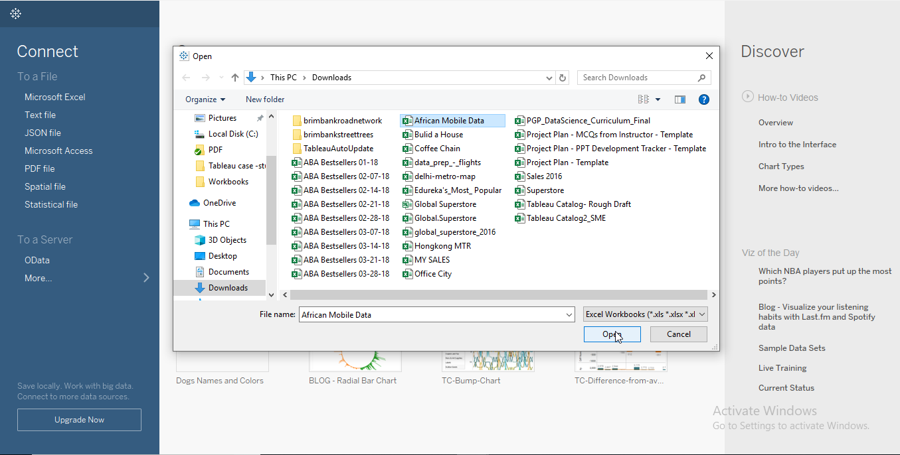

**Step 2:** Drag and drop the sheets that is “African mobile data” sheet on flow pane, join sales data and salesperson data. Click on Sheet1.

Go to sheet and rename the sheet to “Comparative sales”

**Step 3:** Drag and drop the required fields from dimensions and measures to column and row shelf.

* Contracts sold to columns.
* Salesperson to rows.

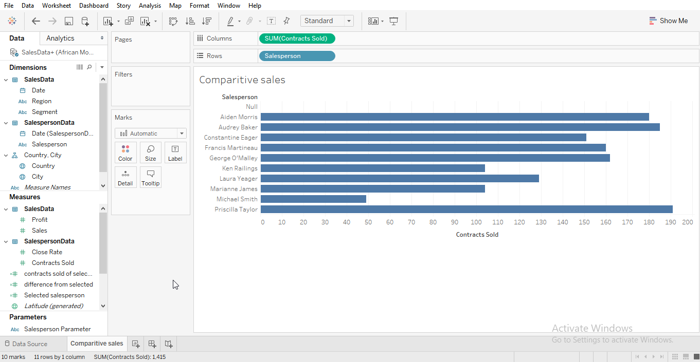

Create a parameter for salesperson for selection.

**Step 4:** To create a Parameter, click on the drop down on salesperson and select create parameter.

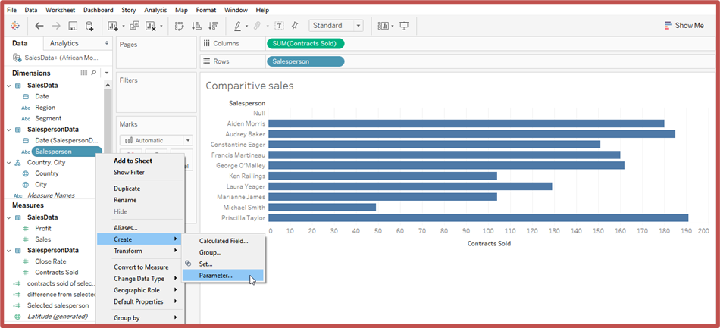

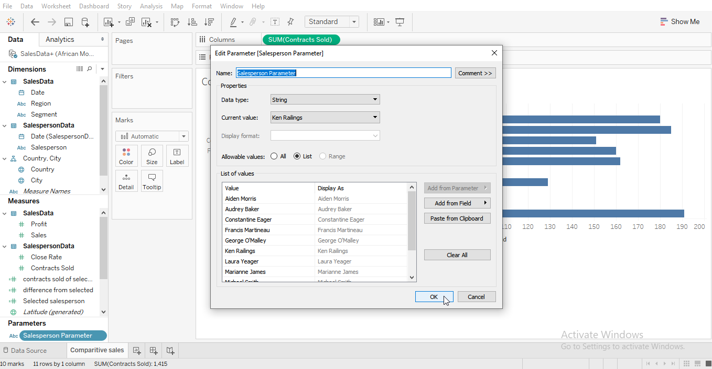

To make the parameter dynamic, create a calculated field to know the contracts sold by salesperson.

**Step 5:** To create the calculated field, click on drop down on top right next to dimensions and select create calculated field.

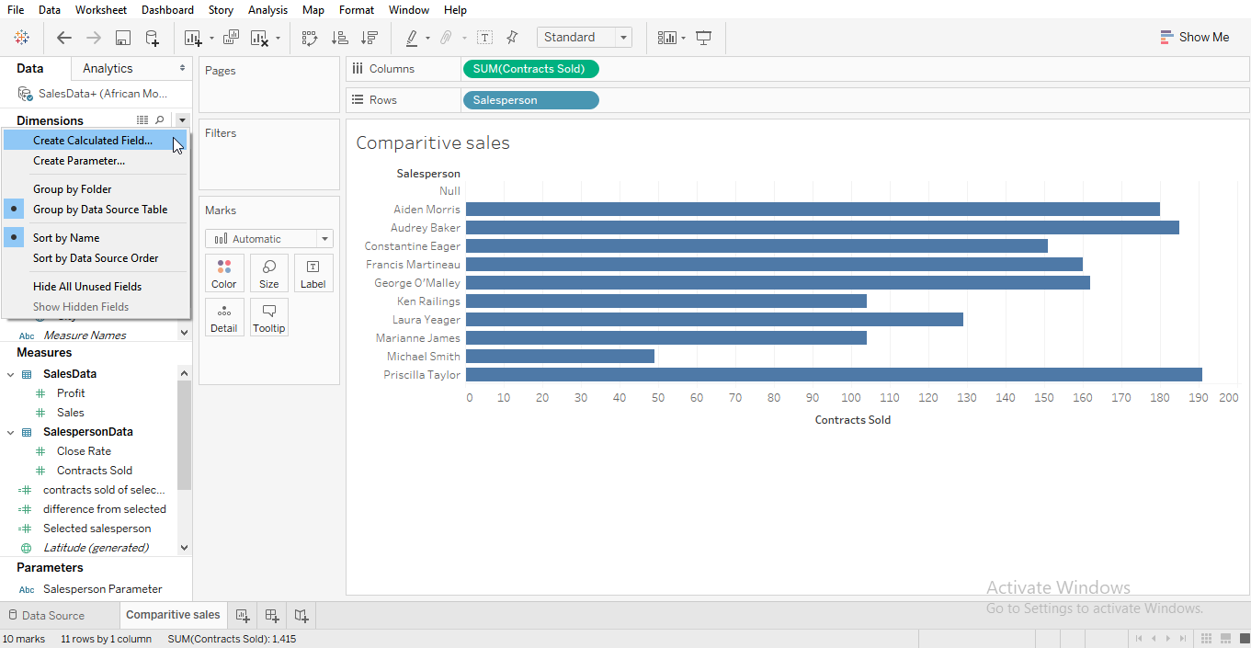

Name the field as selected salesperson. Add the following calculation and click ok.

**Step 6:** Add an LOD expression which makes easy to compare contracts sold of each salesperson to selected salesperson.

**Step 7:** Add a calculated field accordingly, to create the calculated field, click on drop down on top right next to dimensions and select create calculated field.

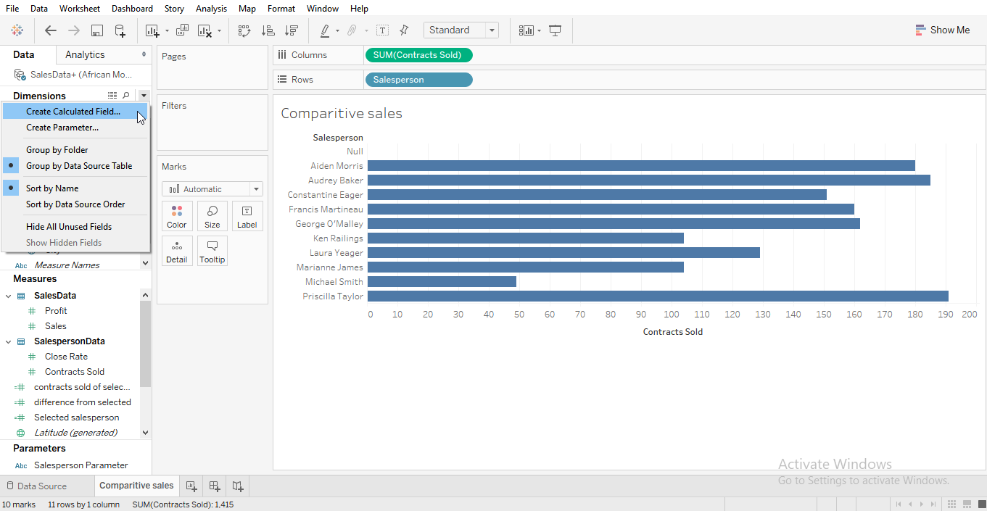

Name the field as contracts sold of selected salesperson. Add the following calculation and click ok.

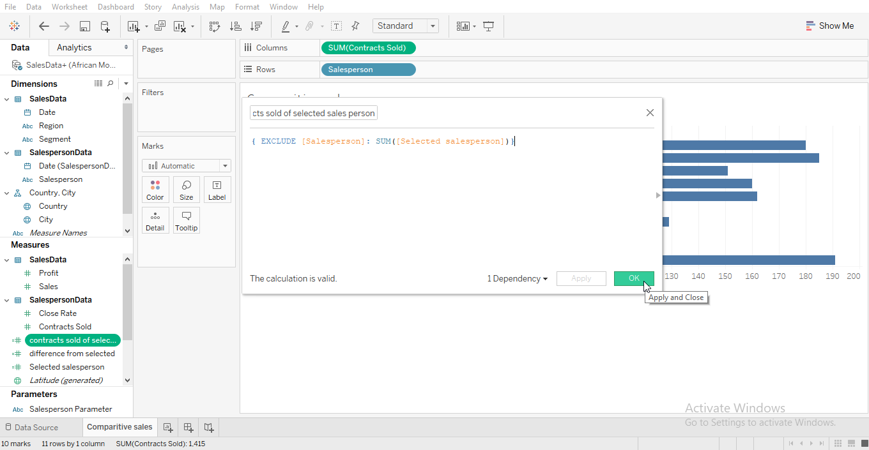

Now, that you have applied the LOD expression and the contracts sold of selected salesperson is reflecting on each column its now easy to find difference with the normal calculation.

**Step 8:** To create the calculated field, click on drop down on top right next to dimensions and select create calculated field.



Name the field as difference from the selected. Add the following calculation and click ok.

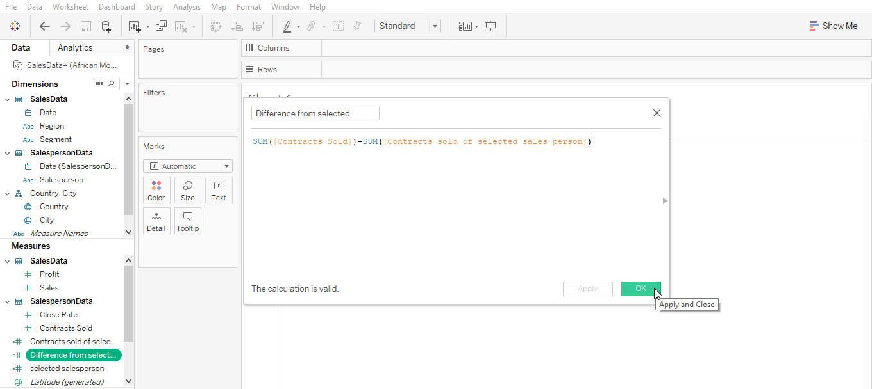

**Step 9:** Add selected salesperson and difference from selected to rows.

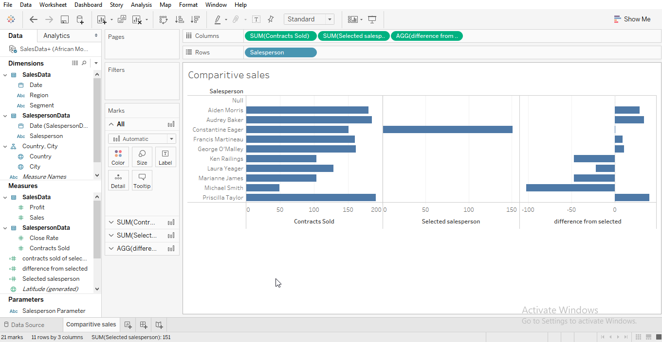

**Step 10:** Add parameter to the view to switch between salesperson.

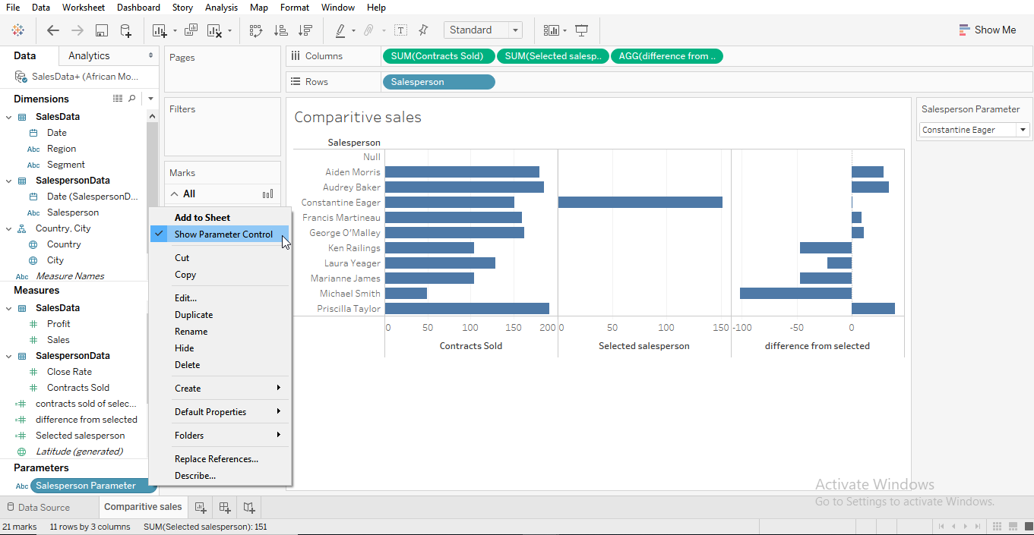

You can now switch between the salesperson and view the difference.

